Hello!
The IRES Foundation’s National School on Market Regulation is an annual conference which attracts compliance officers and key market regulation professionals from insurance organizations and law firms across the country. The School offers an exceptional opportunity to learn about current trends and best practices in market regulation and network with state insurance regulators.
The School also offers an effective way to reach a highly targeted and focused industry audience. Some of the industry’s leading service providers have discovered the School to be one of their most effective marketing efforts.
As chair of the IRES Foundation Sponsorship Committee, I invite you to check out the following information which includes details on the various sponsorship levels. These sponsorship packages have been designed to meet a variety of sponsorship/exhibitor needs.
The IRES Foundation works hard to make the School a positive experience for all attendees including our sponsors and exhibitors. I am confident that you will not be disappointed.
Visit www.ires-foundation.org to learn more about the Foundation or for the latest on the 2023 School. If you have questions or need more information, please contact the IRES Foundation at (612) 486-2536.
Thank you for your consideration. I look forward to seeing you in Hilton Head.
Sincerely,
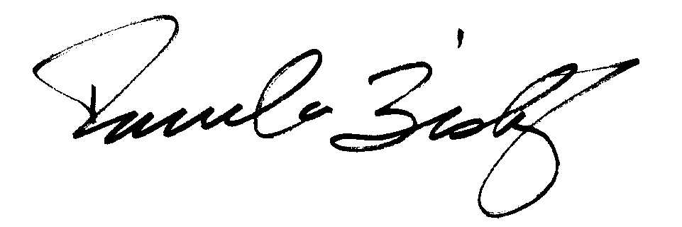
Pamela Bishop

Sponsorship Packages
Bronze Sponsor $550
- Sponsor logo/name on signage throughout the event meeting area
- Sponsor logo/name listed in event materials
- Description of Sponsor on IRES Foundation web site with link to Sponsor’s web site
- Verbal recognition at opening and closing sessions
*Please note that this sponsorship package does not include attendee registration. Please register separately through the IRES Foundation web site.
Silver Sponsor $1,150
- All Bronze benefits, plus
- Exhibitor space for the duration of the event
* Please note that this sponsorship package does not include attendee registration. Any exhibitor representative at the Foundation School must be a registered attendee. Please register separately through the IRES Foundation web site.
Gold Sponsor $2,250
- All Silver benefits, plus
- List of email addresses for registered attendees – post event
- One (1) complimentary school registration
*Please note that this sponsorship package includes one (1) attendee registration. Any exhibitor representative at the Foundation School must be a registered attendee. If you’re interested in attending the conference, please register separately through the IRES Foundation web site.
Platinum Sponsor $5,500
- All Gold benefits, plus
- List of email addresses for registered attendees – pre-event
- Two (2) additional complimentary school registrations (3 total)
*Please note that this sponsorship package includes three (3) attendee registrations. Any exhibitor representative at the Foundation School must be a registered attendee. Please register separately through the IRES Foundation web site.
Diamond Sponsor $7,500 and higher
- All Platinum benefits, plus
- One (1) additional complimentary school registration (4 Total)
- Signature sponsorship of a coffee/snack break with signage
- Signature sponsor of First Timers Reception, Welcome Reception, or Vendor Reception
- Room and time slot for a stand-alone 30-minute vendor session
- Fifty (50) complimentary drink tickets to use at School events
*Please note that this sponsorship package includes four (4) attendee registrations. Any exhibitor representative at the Foundation School must be a registered attendee. Please register separately through the IRES Foundation web site.

Please note: Sponsorship is not guaranteed until payment is received.
For more information about exhibit or sponsorship opportunities, please contact the IRES Foundation office at (612) 486-2536 or send your request via email to office@ires-foundation.org.

Sponsor Agreement Form, Part 1

Sponsor Information
Name of Company / Organization

Name of Contact Person

Title

Address

City |  |  | State | ZIP
Phone | E-mail
WEBSITE ADDRESS

Sponsorship Package  Please check the exhibitor/sponsorship package that interests you.  Bronze Sponsor $550  Silver Sponsor $1,150  Gold Sponsor $2,250  Platinum Sponsor $5,500  Diamond Sponsor $7,500+  I decline the need for a booth at the 2023 School (when applicable). |  | Company Description  Please provide a brief description of your organization for future marketing materials.

Payment
I have enclosed a check (payable to IRES Foundation).

Should you require the ability to make a payment with a different format than listed here, please contact the IRES Foundation office.

Sponsor Agreement Form, Part 2

Deadline: | Sponsor agreements and payment are due by April 1, 2023. Package preference is awarded on a first-come, first-served, space-available basis, so return your agreement soon.
Cancellation policy: | Cancellations must be received in writing. The following refund schedule will apply:  Refund Cancellation Date  100% refund before January 31, 2023  50% refund January 31, 2023 to April 1, 2023  No Refund April 1, 2023 and after
Logo visibility: | Your company’s logo will be used in School promotional materials. In order to take full advantage of this benefit, you must send your company’s logo to the IRES Foundation office by April 1, 2023 as a vectored-art EPS file. (If your company does not have its logo in this format, contact the IRES Foundation office for alternatives.) Email logos to office@ires-foundation.org.
Exhibit tables: | Each exhibit will include one draped 6'x30" table and two chairs. Your exhibit space will be approximately 6'x8'. All exhibition materials must fit in that area. All road cases and/or boxes must not be seen or cleared from the area. Exhibit tables will be assigned as payment is received. Some locations are reserved for conference sponsors; others are assigned on a first-come, first-served, space availability basis. All sponsorship packages come with a complimentary exhibit table. If you do not wish to use your exhibit space, please notify the IRES Foundation office of your decision as soon as possible.
Exhibit hours: | Exhibit hours will be 8:00 a.m. to 6:15 p.m. on Monday, April 17, 2023 and 8:00 a.m. to 12:15 p.m. on Tuesday, April 18, 2023.
Exhibitor attendance: | Any exhibitor onsite must be a paid registrant or use one of the company’s complimentary registrations, depending on the sponsor level. Exhibitor representatives are free to register onsite, but must pay at the door – invoices will not be sent.
Security: | The exhibit area is unsecured, although it is a space that is separate from the general facility guest traffic. Details and map are available upon request. Exhibit materials left overnight in the facility are at the exhibitor’s risk.
Liability: | Each exhibitor will be responsible for the space leased during the convention and will keep it free from hazards to persons on the premises. The IRES Foundation and its members will not be responsible for any injury that may occur due to exhibit operators, their associates, or employees. It is agreed that in no case shall the IRES Foundation and its members be responsible for any loss, theft or damage by fire, or any injury to any person or article. Each exhibitor is responsible for complying with all federal, state, local and conference facility fire, and safety codes.
Electrical, AV, Internet, and Telephone: | Electricity, audio/visual equipment, internet, and telephone lines are limited and will be ordered on a first come first serve basis. All requests for electricity, audio/visual, internet, and telephone lines should be made in advance with the Hotel directly. Placement of each exhibitor is in sole discretion of IRES Foundation and Hotel staff. The additional charges for all technology needs will be the financial responsibility of the exhibitor, not the IRES Foundation. The Hotel, not IRES Foundation, is responsible to provide these services.

I agree to abide by the rules and considerations detailed in this agreement.
Signature | Date

